**EXPERIMENT 6**

**DML COMMANDS (COLLEGE SCHEMA)**

**Aim:**

* Insert 5 instances into the tables created in experiment 6.
* Display the tables.
* Add attribute course to student table then insert values.
* Use update to set course for students.
* Delete an attribute.

**Components:**

* Instance: It is a collection of information stored in a database at a particular moment.
* Entity: Object that is relevant to the given system. It is represents as a rectangle.
* Attribute: Trait of an entity , relationship or other attribute .It is represented by oval.
* Primary Key: A primary key is a set of column or a set of columns in a whose uniquely identify row in a table.

**Schema:**

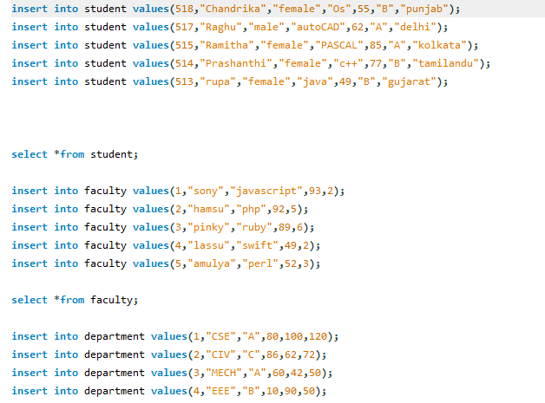

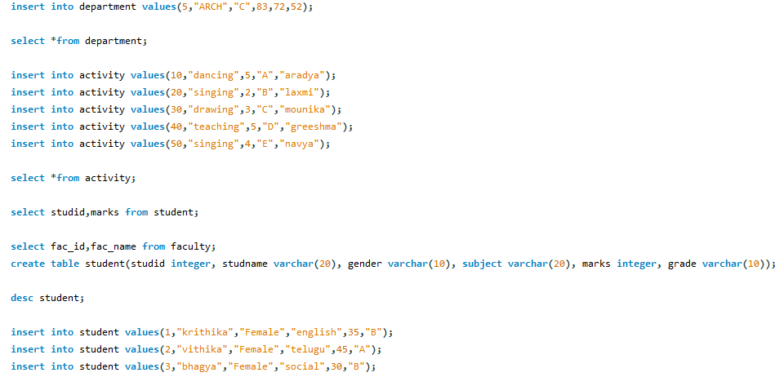

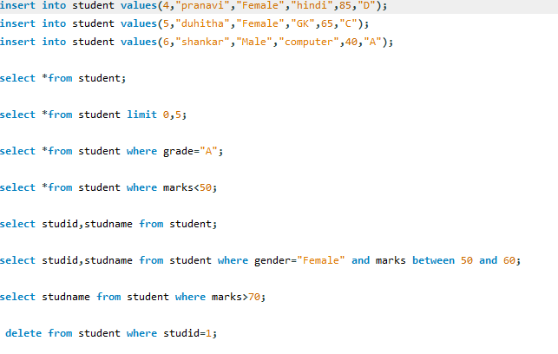

**Output:**

